**Annexure – I**

**PART A – Micro-Project Proposal**

**Grocery Ordering System using Javascript**

1. **Brief Introduction :**

**JavaScript** is a versatile programming language commonly used for web development. In our Book Ordering System, JavaScript is used to add interactivity and functionality to web pages. It enables dynamic features like updating book information, handling user interactions, and managing the shopping cart.

**Event Handling** is a key concept in JavaScript. It involves responding to user actions, such as clicks or form submissions. In our system, event handling ensures that when a user clicks a book to add it to the cart, the system captures that action and updates the cart accordingly, providing a seamless and user-friendly experience.

**2.0 Aim of the Micro-Project :**

To develop Online Books Ordering System using JavaScript

**3.0 Intended Course Outcomes :**

1. Create interactive webpages using program flow control structure
2. Implement Array & Functions in JavaScript
3. Create event based web forms using JavaScript
4. Create interactive webpage using regular expression for validations

**4.0 Literature Review :**

A literature review of book ordering systems implemented in JavaScript reveals their significance in enhancing the online shopping experience. These systems facilitate efficient book selection, offer user-friendly interfaces, and streamline payment processes. They also emphasize security to protect user data and transactions. The literature emphasizes the importance of responsive design for mobile users and highlights the role of JavaScript in creating dynamic and interactive features. Overall, the reviewed literature underscores the growing importance of JavaScript-based book ordering systems in modern e-commerce.

**4.0 Proposed Methodology :**

1. Discussion about given topic.

2. Selection of good leader and distribution of responsibilities.

3. Collection of information using different resources.

4. Analysis of given information.

5. Representation information in required formats.

6. Preparation of project report.

7. Completion and submission of assigned task.

**5.0 Resources Required** :

|  |  |  |  |  |  |
| --- | --- | --- | --- | --- | --- |
| **Sr.no.** | **Name of resource** | **Specification** | **Quantity** | **Remarks** | |
| 1 | PC | Intel(R) core2DUO CPU 67500@2.93 GH2 RAM 2.00  64-bit Windows OS | 01 |  | |
| 2 | Internet | Www.geeksforgeeks.org  Www.tutorialspoint.com | 01 |  | |
| 3 | Books | JavaScript : The Good Parts. | 01 |  |  |

**6.0 Action Plan** :

|  |  |  |  |  |
| --- | --- | --- | --- | --- |
| **Sr.no** | **Details of activity** | **Planned started date** | **Planned finished date** | **Numbers of members** |
| 1 | Collection of information |  |  | 3 |
| 2 | Analysis of information |  |  |
| 3 | Representation of information |  |  |
| 4 | Preparation of report |  |  |
| 5 | Completion of assigned task |  |  |

**Annexure – II**

**PART B – Micro-Project Report**

**Book Ordering System using Javascript**

**1.0 Rationale :**

The Book Ordering System in JavaScript (JS) is a user-friendly web application designed to simplify the process of buying books online. This system leverages the power of JS to create an interactive and responsive platform for users. It allows users to browse a collection of books, view book details, and add them to their shopping cart. Event handling in JS ensures smooth interactions, such as adding books to the cart and processing orders. The system also provides a secure and efficient way to complete purchases, enhancing the overall book-buying experience for customers. Through the application of JS and event handling, the Book Ordering System delivers a convenient and enjoyable online book shopping solution.

**2.0 Course Outcomes Addressed :**

1. Create interactive webpages using program flow control structure
2. Implement Array & Functions in JavaScript
3. Create event based web forms using JavaScript
4. Create interactive webpage using regular expression for validations

**3.0 Literature Review :**

A literature review of book ordering systems implemented in JavaScript reveals their significance in enhancing the online shopping experience. These systems facilitate efficient book selection, offer user-friendly interfaces, and streamline payment processes. They also emphasize security to protect user data and transactions. The literature emphasizes the importance of responsive design for mobile users and highlights the role of JavaScript in creating dynamic and interactive features. Overall, the reviewed literature underscores the growing importance of JavaScript-based book ordering systems in modern e-commerce

**4.0 Actual Methodology Followed :**

1. Discussion about given topic.

2. Selection of good leader and distribution of responsibilities.

3. Collection of information using different resources.

4. Analysis of given information.

5. Representation information in required formats.

6. Preparation of project report.

7. Completion and submission of assigned task.

**5.0 Actual Resources Used :**

|  |  |  |  |  |  |
| --- | --- | --- | --- | --- | --- |
| **Sr.no.** | **Name of resource** | **Specification** | **Quantity** | **Remarks** | |
| 1 | PC | Intel(R) core2DUO CPU 67500@2.93 GH2 RAM 2.00  64-bit Windows OS | 01 |  | |
| 2 | Internet | Www.geeksforgeeks.org  Www.tutorialspoint.com | 01 |  | |
| 3 | Books |  | 01 |  |  |

**6.0 Outputs of the Micro-Project :**

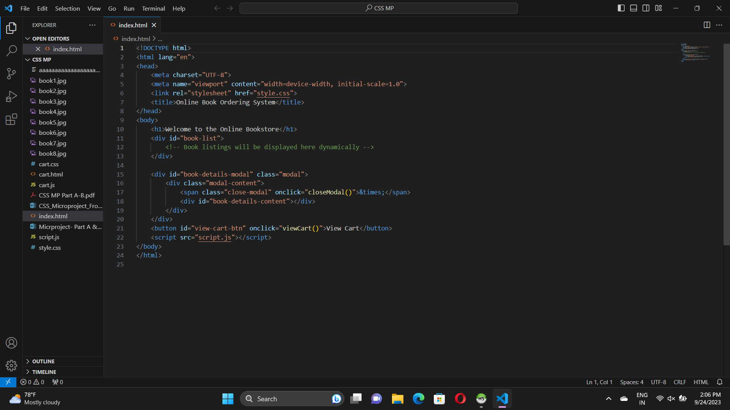

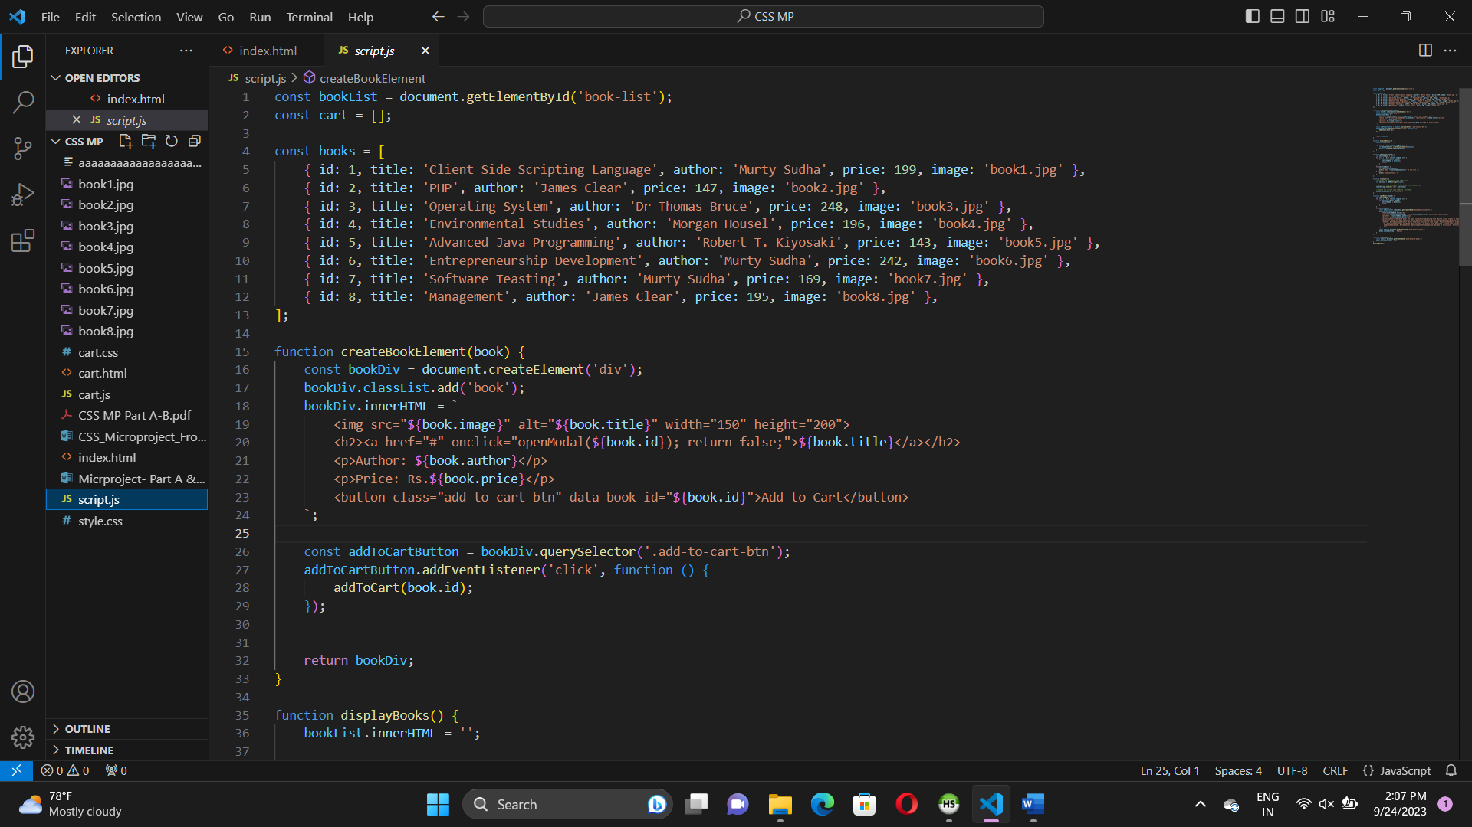

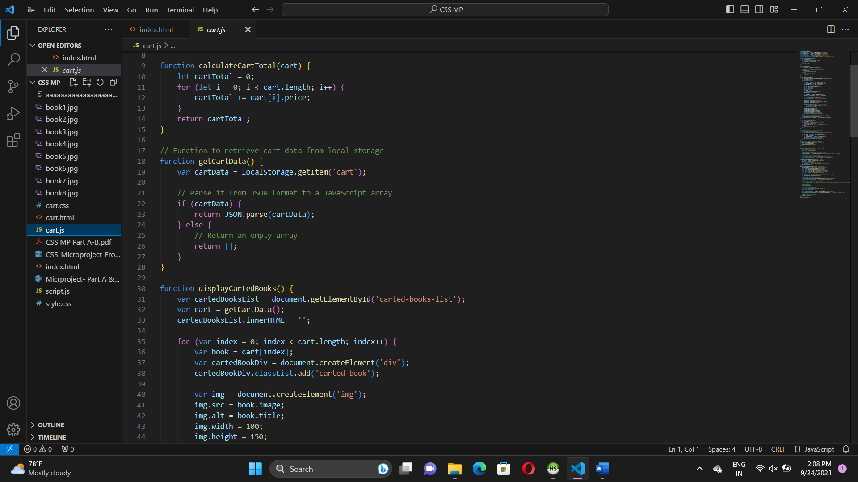

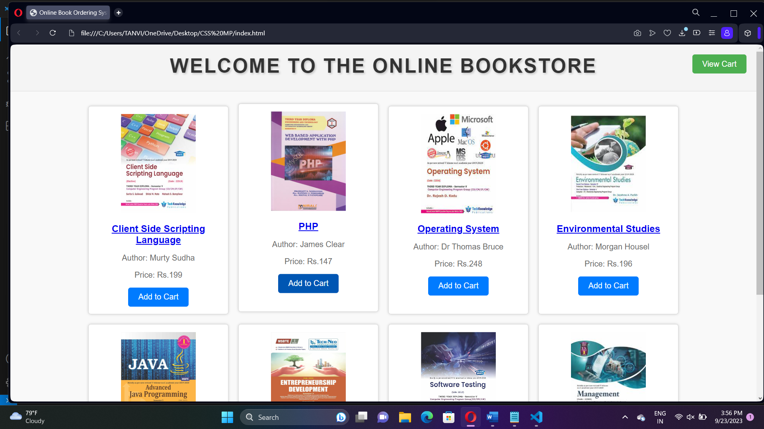

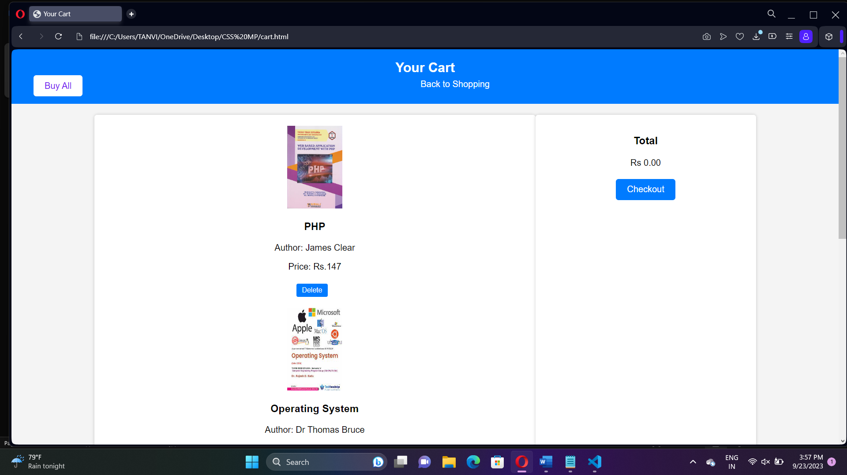

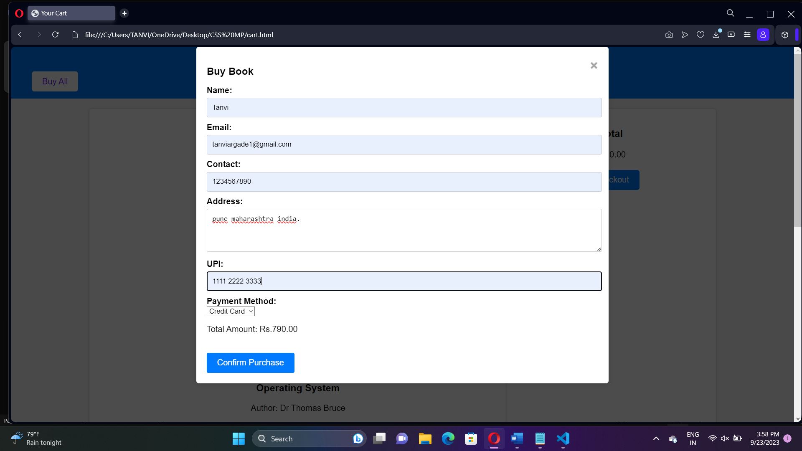

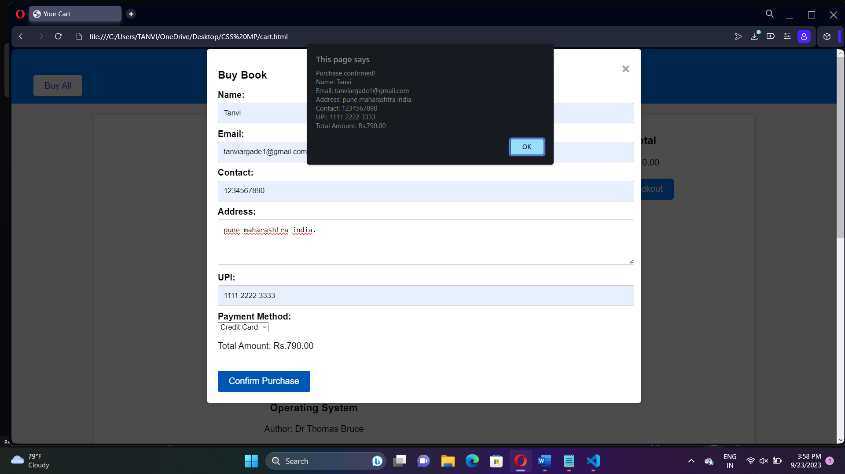

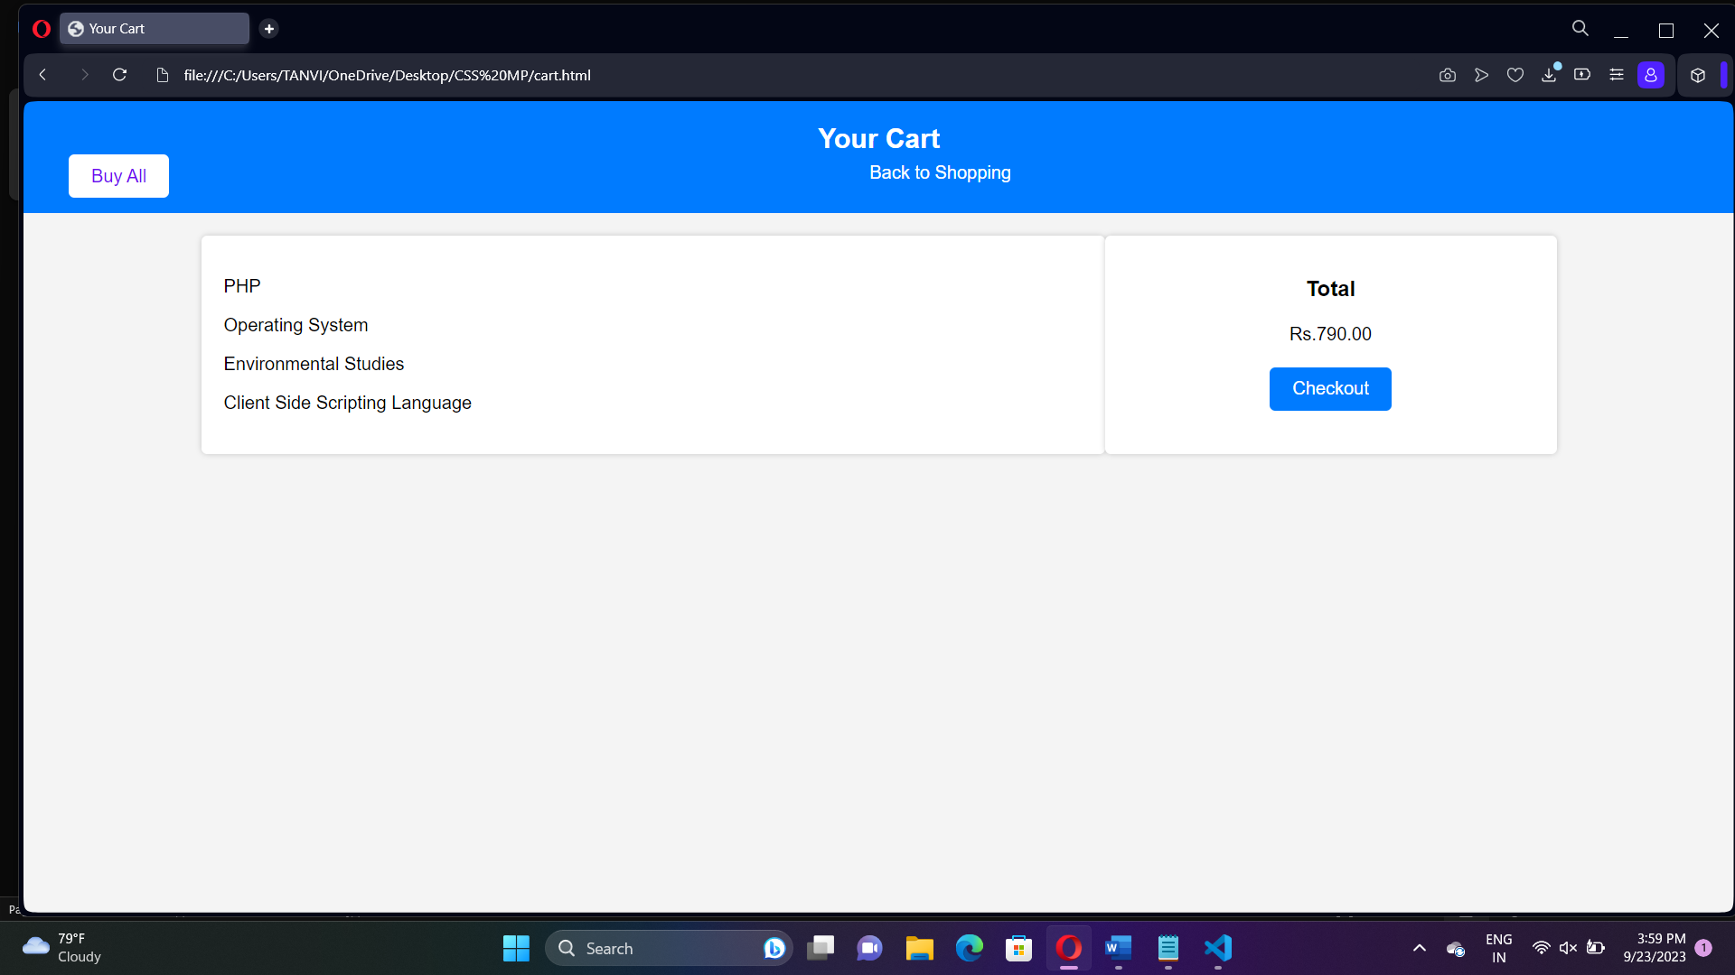

**7.0** **Skill Developed / learning out of this Micro-Project :**

1. Analytical and logical skills
2. Interpretation of data
3. Demonstrated working as a leader/a team member
4. Followed safety practices
5. Followed ethical practices
6. Maintained tools & equipment

**8.0 Applications of this Micro-Project :**

JavaScript is commonly used for creating web pages. It allows adding dynamic behavior to the webpage and adding special effects to the webpage.

**9.0 Area of Future Improvement :**

We have developed webpage with basic JavaScript functionalities. In future we would like to add various additional features to our webpage.